

10/15/2023

Student Name: Nomsa Tadiwanashe Kachere

Student Number: M00883591

Lab Tutor: Mrinal Sharma

Student Name: Nomsa Tadiwanashe Kachere

Student Number: M00883591

Lab Tutor: Mrinal Sharma

CST2120 Web Applications and Databases

Game Website Report

Table of Contents

Table of Figures 2

Introduction 3

Homepage (index.html) 3

Game Page (game.html) 4

Game instructions 5

Game Page Screenshots 6

Leaderboard Page (leaderboard.html) 7

Login Page 8

Sign Up Page (signup.html) 10

Implemented Validation 11

Stored Data 11

Sign Up Page Screenshots 11

About Creator (aboutcreator.html) 13

Conclusion 13

# Table of Figures

Figure 1: Homepage Top Half 3

Figure 2: Homepage Bottom Half 4

Figure 3: Game Options Menu 6

Figure 4: The game in action 7

Figure 5: The game over pop up 7

Figure 6: The leaderboard 8

Figure 7: The leaderboard being hovered over 8

Figure 8: The login page 9

Figure 9: Error for incorrect username 9

Figure 10: Error for incorrect password 10

Figure 11: Session Storage when user is logged in 10

Figure 12: Sign up page top half 11

Figure 13: Sign up page bottom half 12

Figure 14: Local Storage 12

Figure 15: About Creator Page 13

# Introduction

Enclosed within the pages of this comprehensive report are highlights of the development of Starfire Blitz, an exciting web-based game. In this document, a deeper look is taken into the website as well as the game itself.

## Homepage (index.html)

The homepage is the central point of the website. The header contains the “Login” and “Sign Up” buttons as well as links to the home, game and leaderboard pages. Within the footer, links to different social media networks can be found as well as a link to the “About Creator” page.

A game description box is found in the centre of the page. It reveals a short game description when hovered over.

When the player clicks the “Login” button, they are redirected to the login page (login.html).

The “Sign Up” button redirects the user to the signup page (signup.html).

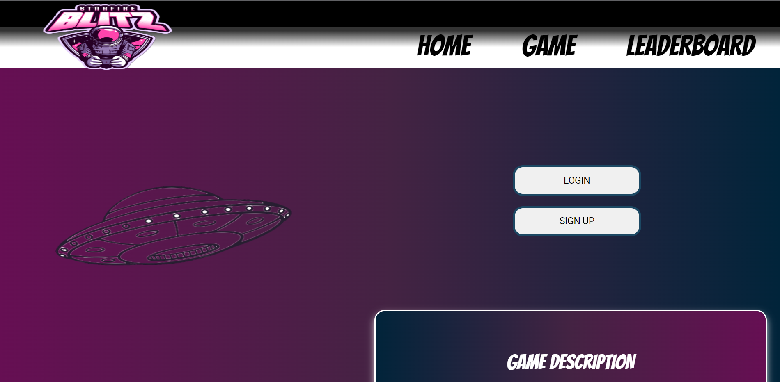

Figure : Homepage Top Half

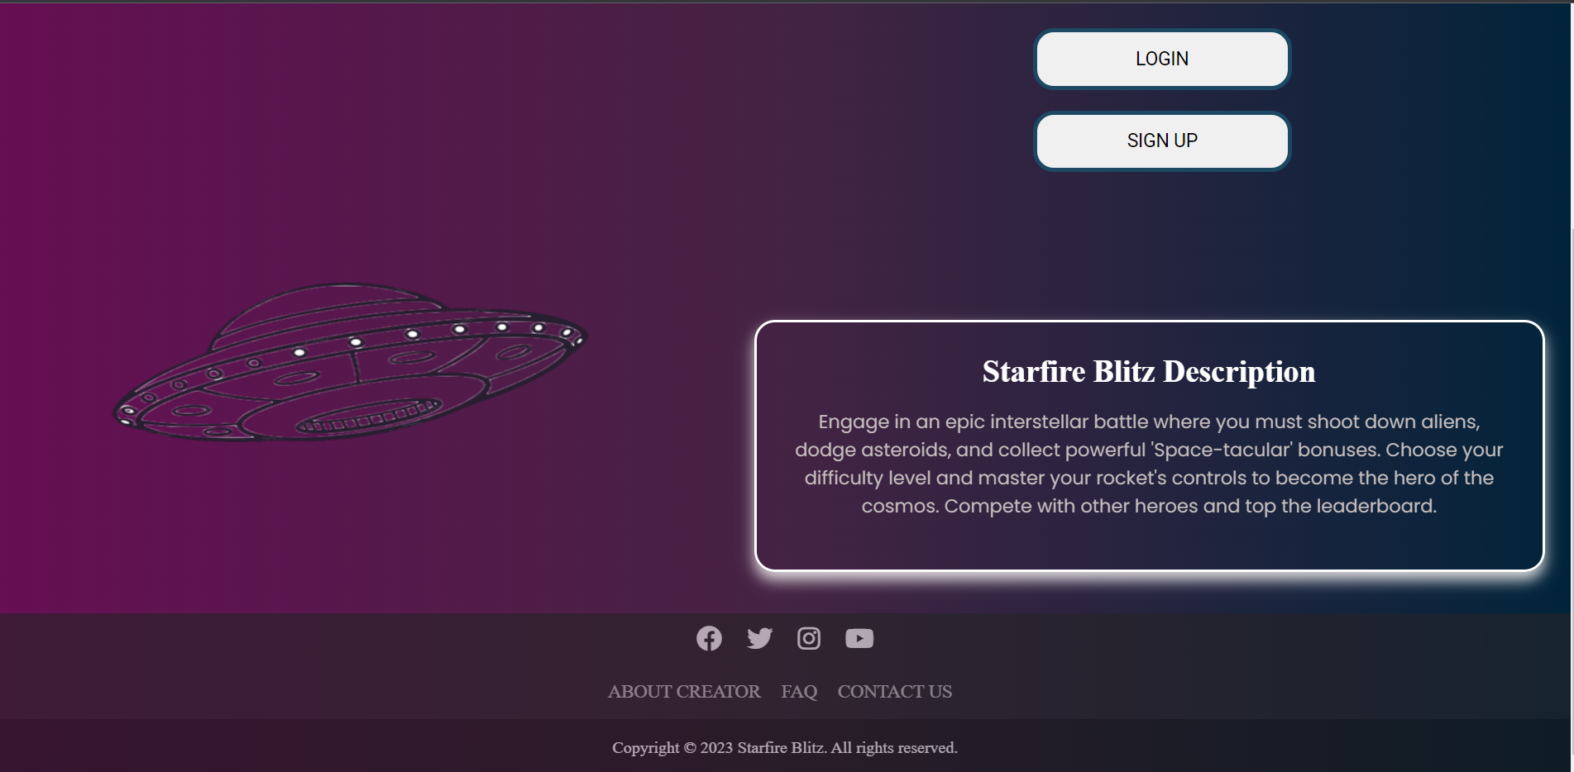

Figure : Homepage Bottom Half

## Game Page (game.html)

#### Game Characters

The central figures in the game are the invaders which move both horizontally and vertically across the canvas. The invaders move at a constant speed and spawn on the top left side of the canvas at regular time intervals. Upon being shot by the player, there’s an animation invoked that gives the effect of an explosion.

The enemy ship moves horizontally along the top of the canvas at a constant speed; firing pink projectiles with the aim of destroying the player’s rocket. When shot by the player, there’s an animation invoked that gives the effect of an explosion.

The player’s rocket moves horizontally along the bottom part of the canvas. It shoots out orange projectiles designed to destroy the invader forces and the enemy spaceship. The player is limited to having a maximum of two projectiles in the air at any given time, introducing a tactical element to the gameplay.

#### Lives

At the beginning of the game, the player is granted five lives. One life is lost every time the player’s rocket is hit by the enemy projectiles. Once all five lives are lost, the game is over. Moreover, the game ends when an invader comes in contact with the player’s rocket at the bottom of the canvas. The player’s life count is displayed on the right side of the canvas and changes dynamically.

#### Bonuses

Bonuses are available to provide the player with an advantage against the invaders. In order to acquire these bonuses, the player’s rocket must intercept them before they reach the bottom of the canvas. The available bonuses are:

1. The ‘2x Multiplier’ which doubles the player’s score.
2. The ‘Extra Life Booster’ grants the player an additional life.
3. The ‘Random Boost Box’ randomly grants the player either of the previously mentioned bonuses.

#### Game Difficulty

The game has two difficulty levels: ‘Beginner Cadet’ and ‘Seasoned Protector’. The ‘Beginner Cadet’ serves as the default and easier level. As the game difficulty increases in the ‘Seasoned Protector’ level, various constraints are applied to the game.

The constraints are as follows:

1. The enemy spaceship fires more projectiles.
2. An increase of speed in invader movement.
3. An increase of speed in bonus movement.

#### Score Display

The score is displayed on the right side of the canvas. The score changes dynamically keeping the player informed on their current score.

#### Pause/Play Button

The player is able to pause and play the game at their convenience using the ‘play/pause’ button which is situated on the left side of the canvas.

#### Pop Ups

Once the player successfully logs in, a game options menu pops up. Within this popup menu, the options to play and change the game difficulty level are contained. Furthermore, the player is able to access the leaderboard from this menu.

Once the game ends, a “Game Over” popup is displayed. This pop up contains the player’s final score, the number of shots they fired and how many of those shots were on target. Additionally, the game can be restarted from there.

#### Game Music

The game music is intended to add an extra entertainment element for the player. The music only plays when the game is not paused. Once it is paused, the music pauses as well.

#### Logout

The user icon contains a dropdown that enables the current player to log out of the game. Once logged out the player is redirected to the login page.

#### Complex JavaScript

The use of complex JavaScript in the game includes:

1. OOP (Classes)
2. Animations
3. Multiple skill levels
4. Timers
5. Graphics
6. Game music

### Game instructions

#### How to play the game

To play the game, the player moves the rocket using the left and right arrow keys on their keyboard. The rocket moves in a single plane, horizontally.

The spacebar button enables the player’s rocket to shoot out projectiles. Every time the spacebar is clicked, a projectile is launched from the rocket. The player is limited to a maximum of two projectiles in the air at a time.

#### Aim of the game

The aim of the game is to eliminate invaders and shoot the enemy spaceship as many times as possible whilst avoiding the projectiles the enemy spaceship will be launching. This enables the player to obtain the highest score possible; giving them a chance to claim the top position on the leaderboard.

#### Score Generation

The key source of points is striking down invaders. Eliminating an invader earns the player 10 points, whereas, striking the enemy spaceship earns the player 20 points.

More points can be obtained through the use of the ‘2x Multiplier Bonus’ which doubles the player’s score every time its caught.

### Game Page Screenshots

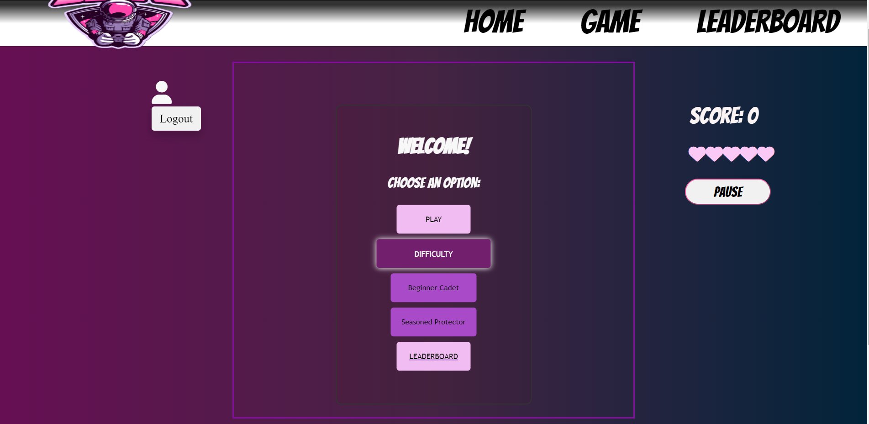

Figure : Game Options Menu

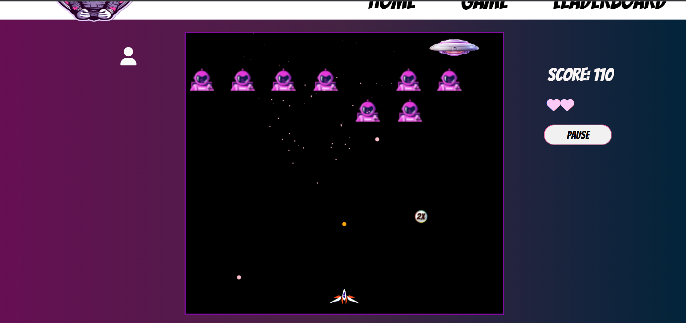

Figure : The game in action

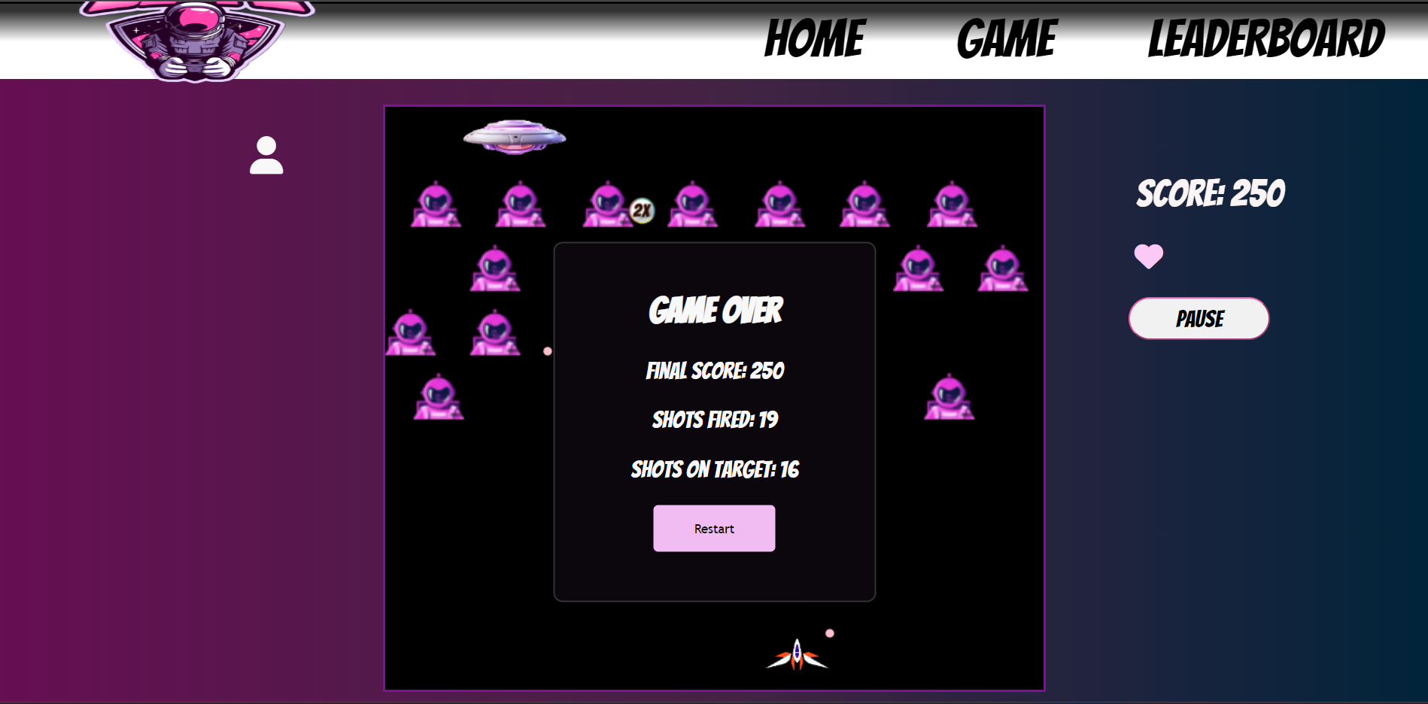

Figure : The game over pop up

## Leaderboard Page (leaderboard.html)

The highest score each registered player attains is displayed on the leaderboard. The scores are sorted and displayed in descending order along with the username of the player who achieved the score.

Each player’s high score is stored in the Local Storage. The high score is fetched from the Local Storage, parsed and displayed in an HTML table that is dynamically generated. If a user obtains a higher score, the ‘high score’ element is updated and the newer score is displayed.

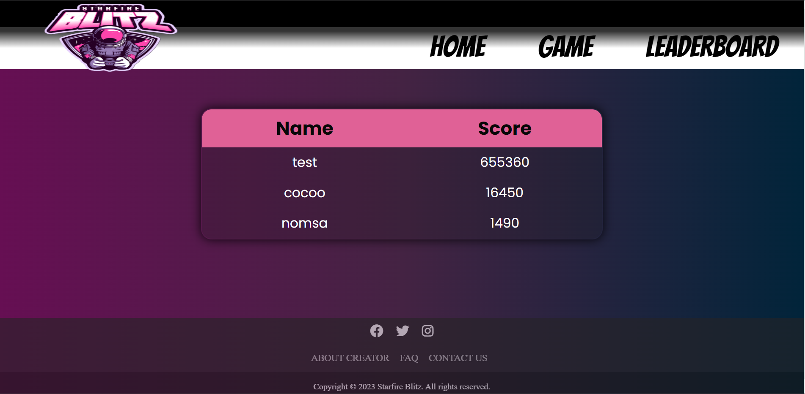

Figure : The leaderboard

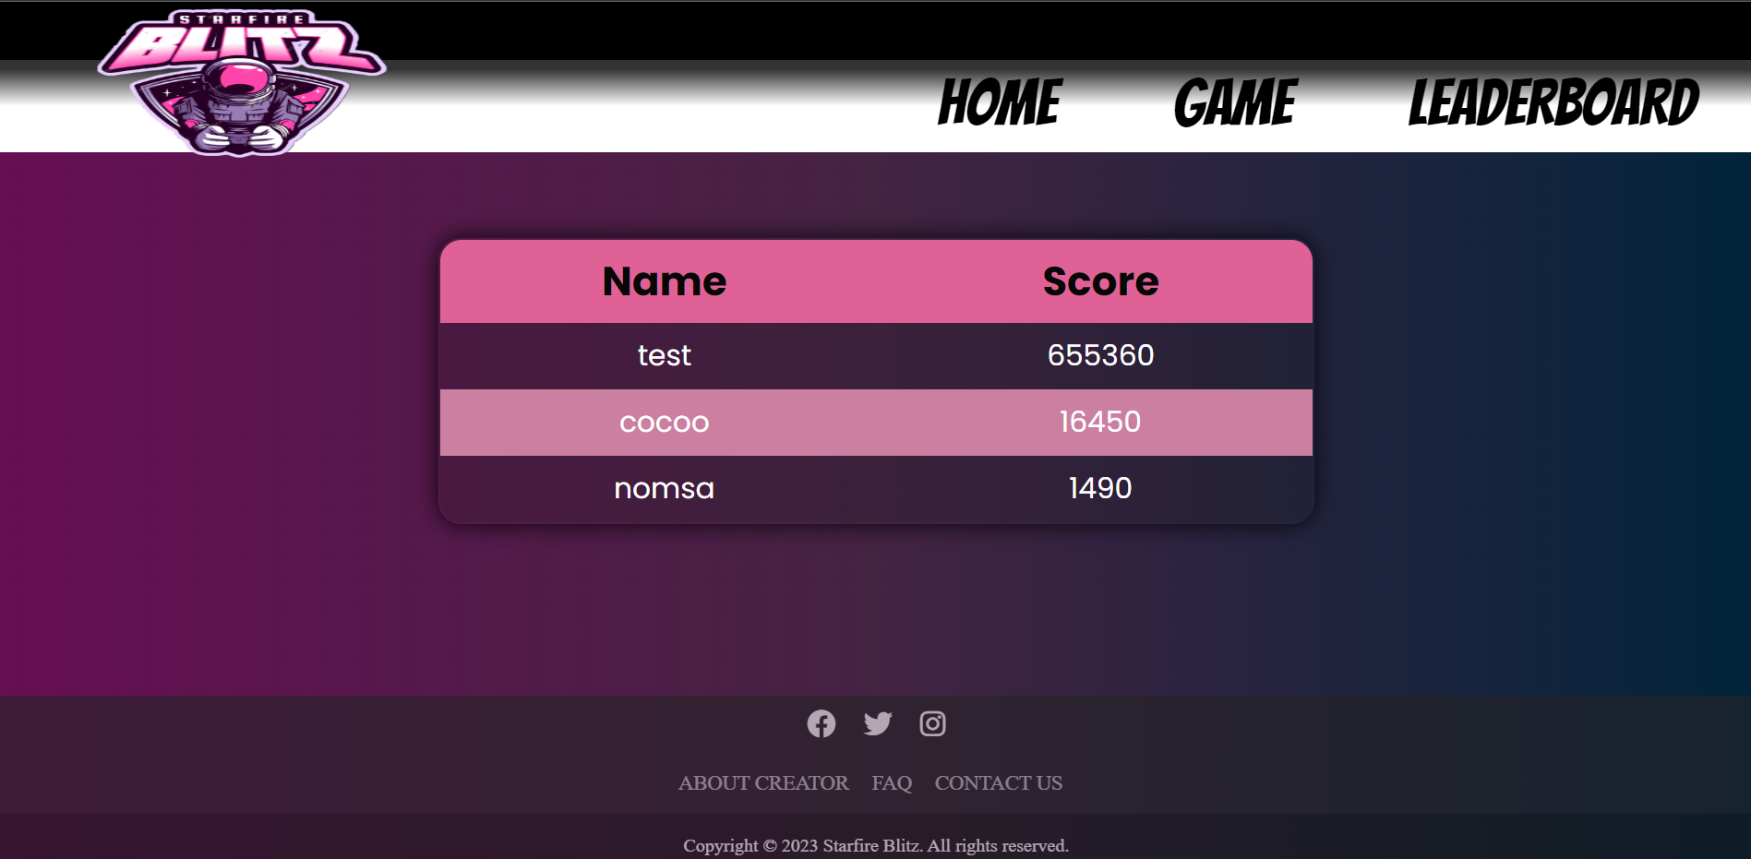

Figure : The leaderboard being hovered over

## Login Page

When logging in, the inputted information is checked against the Local Storage. The username and password have to be stored and match. Upon successful authentication, the player can successfully log in. Once logged in, their data is stored in Session Storage.

The input validation is done using HTML. The user has to enter both fields – username and password – in order for the form to submit.

The error handling is done using Javascript. If a player enters an invalid username or password, they get a respective error message.

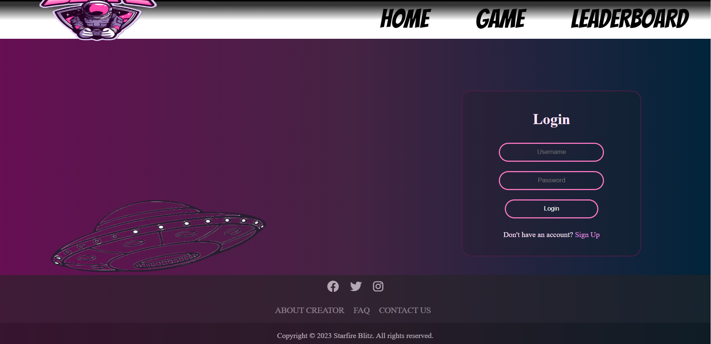

Figure : The login page

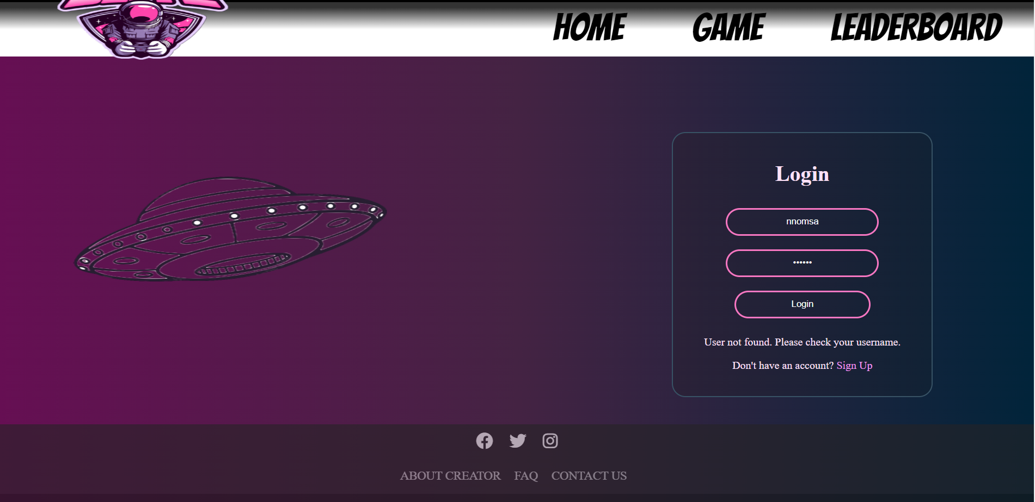

Figure : Error for incorrect username

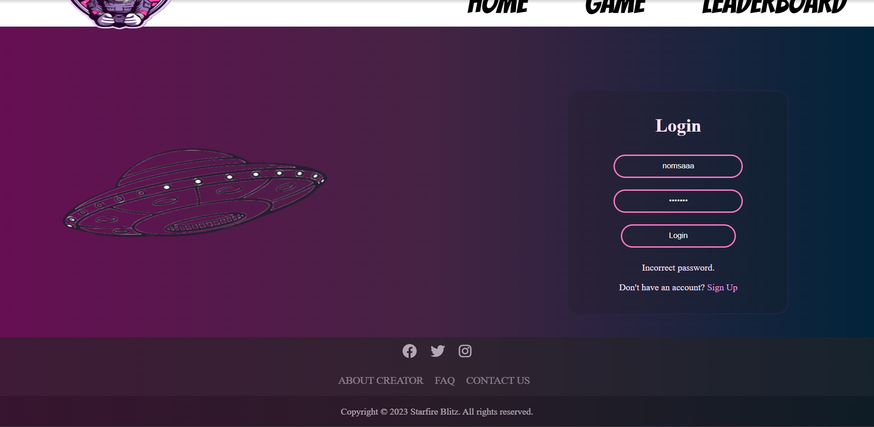

Figure : Error for incorrect password

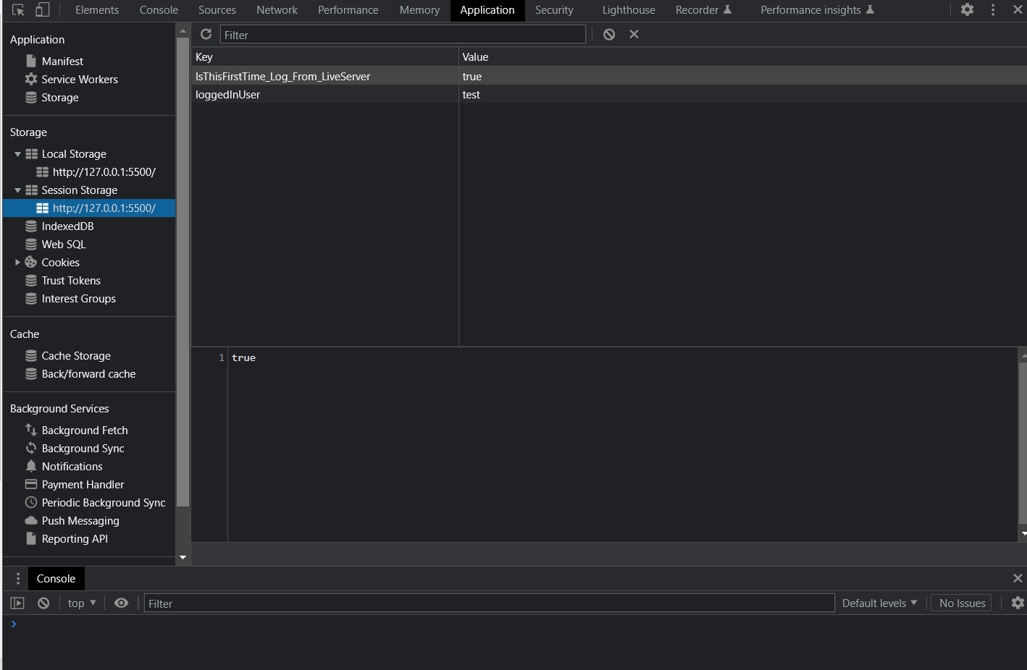

Figure : Session Storage when user is logged in

## Sign Up Page (signup.html)

The player must input five fields of data, namely: Username; Email; Age; Password and Confirm Password. Upon entering the required information, the data is validated. If the data satisfies all the validation requirement, the player’s account is created successfully and the data is stored in the Local Storage.

### Implemented Validation

Validation was done using a combination of HTML and JavaScript. Appropriate error messages are displayed when the user enters invalid data.

The following validation is being implemented:

1. Two users cannot have the same username.
2. The username can only be letters and numbers; special characters are invalid.
3. The user’s email must follow appropriate email address structure.
4. The user has to be at least 12 years old to play the game.
5. Password has to be at least 6 characters long; should include a capital letter and a number.
6. The two inputted passwords should match.

### Stored Data

Data is stored in JSON format. The following user data is being stored:

1. Username
2. Password
3. Email
4. Age
5. Date of account creation
6. High score

### Sign Up Page Screenshots

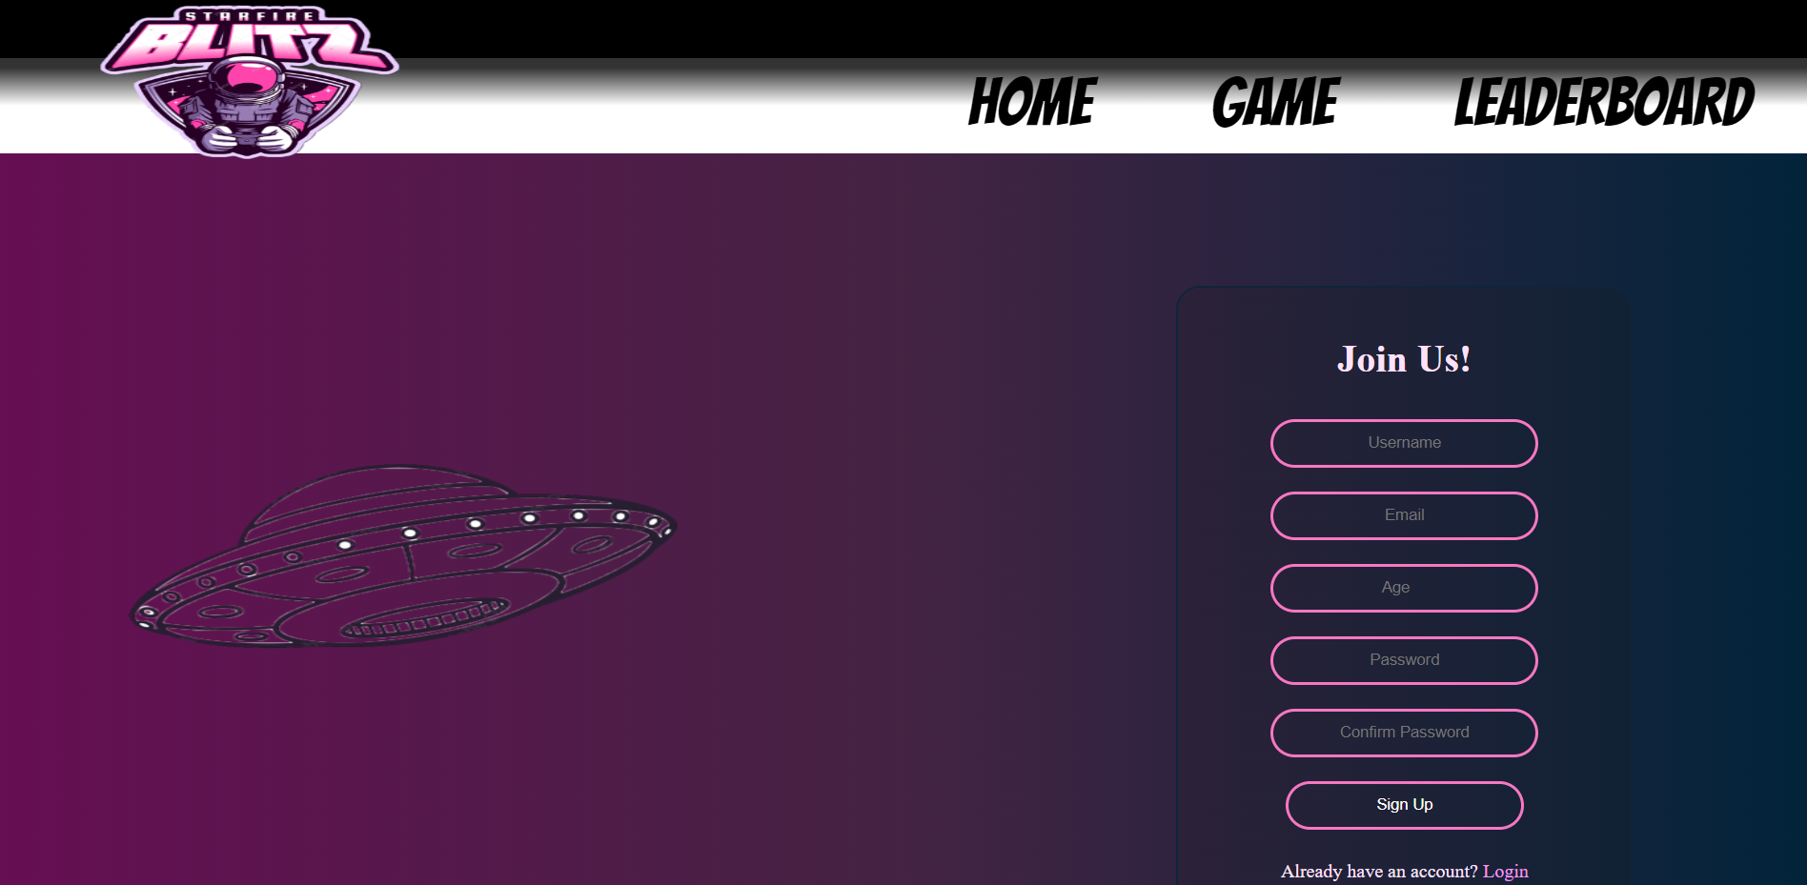

Figure : Sign up page top half

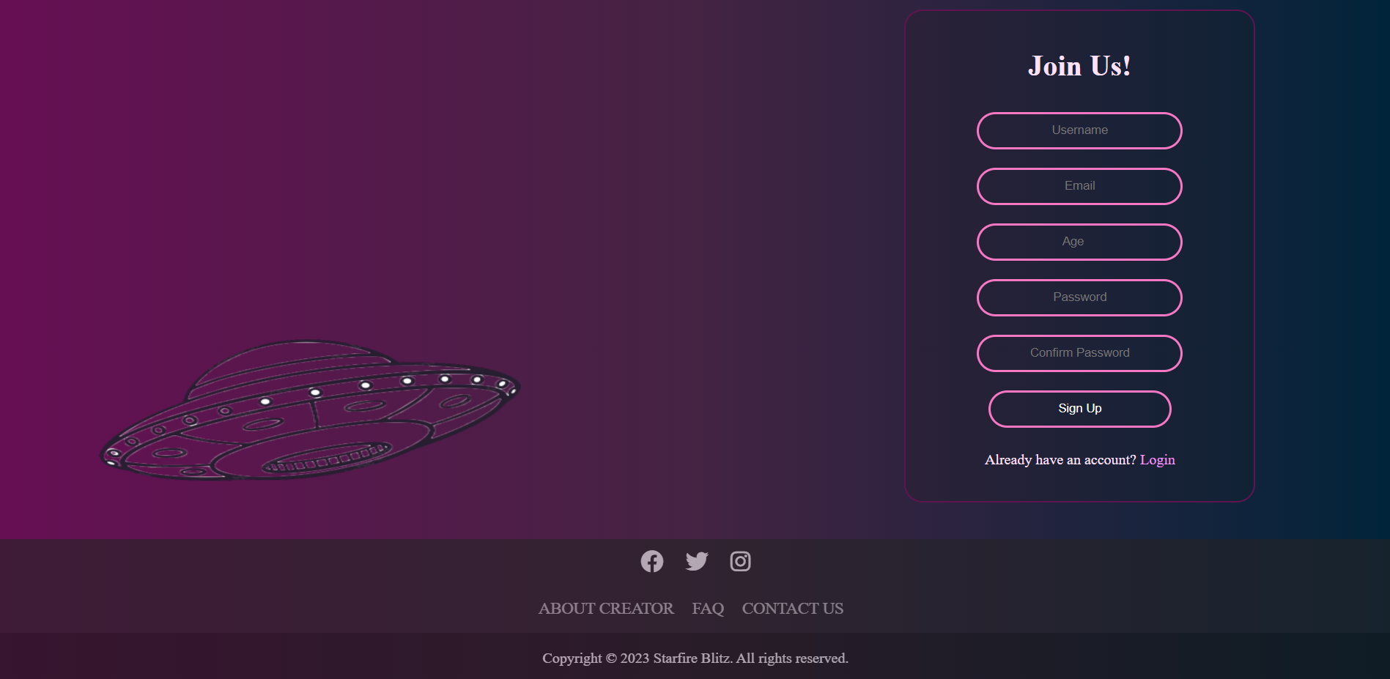

Figure : Sign up page bottom half

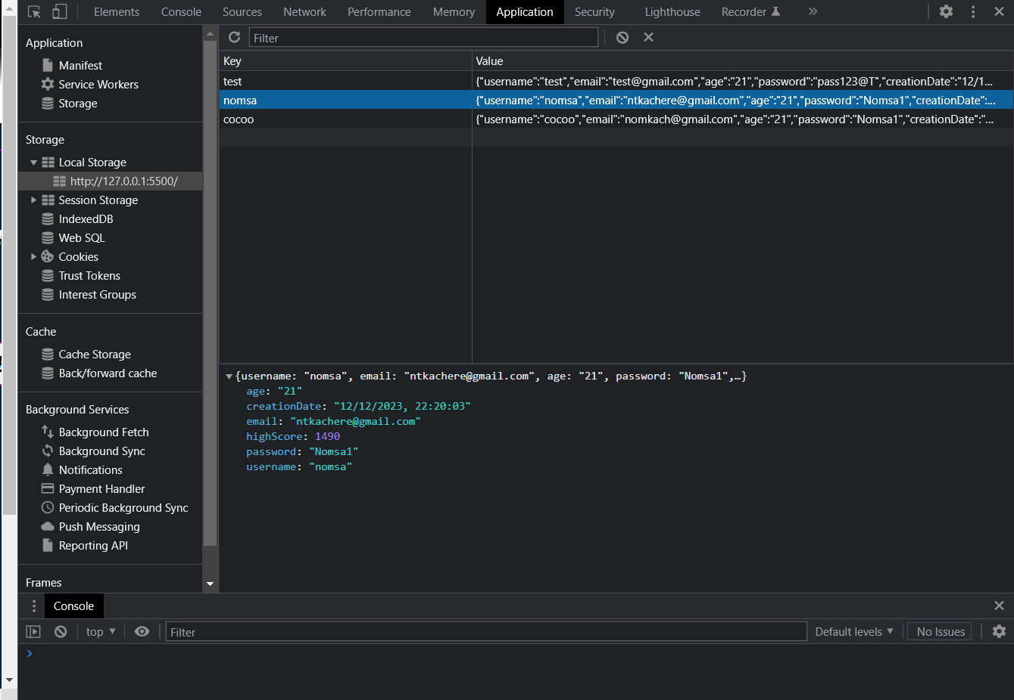

Figure : Local Storage

## About Creator (aboutcreator.html)

This page focuses on the creator of Starfire Blitz, providing the players with a better understanding of her. Links are provided to establish contact with her.

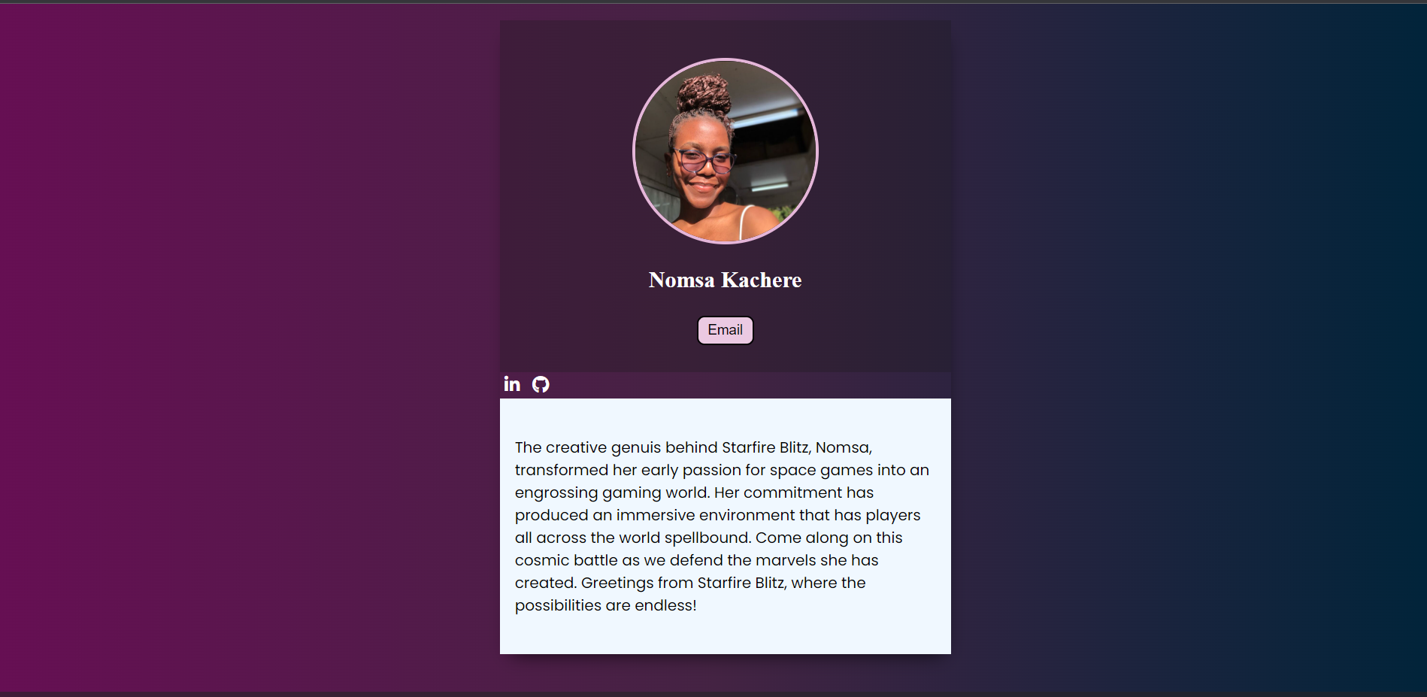

Figure : About Creator Page

## Conclusion

In conclusion, Starfire Blitz is a thrilling and captivating game that will have players stuck on their screens. For the best experience, the game must be played full-screen on 100% zoom. The browser recommended is Chrome. The game must be opened using the Live Server Extension on VS Code.

In this game, I made use of the following technologies: OOP – classes -, instances of those classes, functions, for loops, graphics, animations, game music and timers.